# Feature 1

**Resume Upload & Parsing**

User Flow

1. User navigates to upload page
2. User drags and drops resume file(s) or selects from file browser
3. System uploads file to backend
4. Backend processes document and extracts key information
5. Parsed information is displayed to user for review

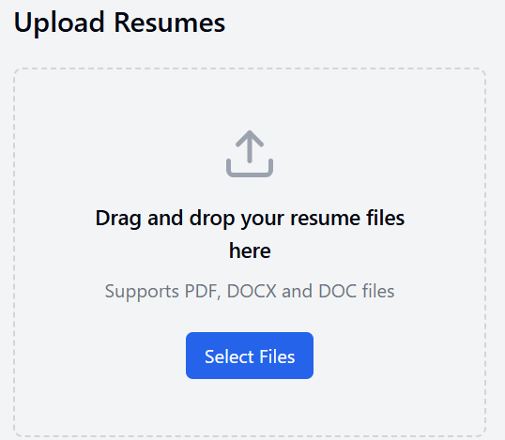

**A screen for dashboard**

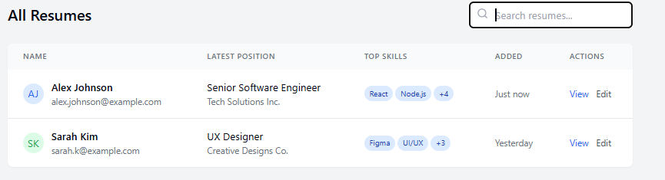

**Something like this-**

[**https://claude.site/artifacts/7ba83c1f-e996-4604-815e-15035ccef77f**](https://claude.site/artifacts/7ba83c1f-e996-4604-815e-15035ccef77f)